**Task 1:-**

TABLE:- Employee

**CREATE DATABASE**

CREATE DATABASE assignment;

**CREATE TABLE WITH COLUMNS**

**TABLE NAME Employee**

CREATE TABLE Employee(EM_ID INT PRIMARY KEY AUTO_INCREMENT,FIRST_NAME VARCHAR(255),LAST_NAME VARCHAR(255),SALARY INT(10),JOINING_DATE DATETIME(6),DEPARTMENT VARCHAR(255));

**DATA INSERT QUERY**

INSERT INTO employee(EM_ID,FIRST_NAME,LAST_NAME,SALARY,JOINING_DATE,DEPARTMENT)VALUES("1","JOHN","ABRAHAM","1000000","2013-01-01","BANKING");

INSERT INTO employee(EM_ID,FIRST_NAME,LAST_NAME,SALARY,JOINING_DATE,DEPARTMENT)VALUES("2","MICHAEL","CLERK","800000","2013-01-01","INSURANCE");

INSERT INTO employee(FIRST_NAME,LAST_NAME,SALARY,JOINING_DATE,DEPARTMENT)VALUES("ROY","THOMAS","700000","2013-02-01","BANKING");

INSERT INTO employee(FIRST_NAME,LAST_NAME,SALARY,JOINING_DATE,DEPARTMENT)VALUES("TOM","JOSE","600000","2013-02-01","INSURANCE");

INSERT INTO employee(FIRST_NAME,LAST_NAME,SALARY,JOINING_DATE,DEPARTMENT)VALUES("JERRY","PINTO","650000","2013-01-01","INSURANCE");

INSERT INTO employee(FIRST_NAME,LAST_NAME,SALARY,JOINING_DATE,DEPARTMENT)VALUES("PHILIP","MATHEW","750000","2013-01-01","SERVICE");

INSERT INTO employee(FIRST_NAME,LAST_NAME,SALARY,JOINING_DATE,DEPARTMENT)VALUES("TESTNAME1","123","650000","2013-01-01","SERVICE");

INSERT INTO employee(FIRST_NAME,LAST_NAME,SALARY,JOINING_DATE,DEPARTMENT)VALUES("TESTNAME2","LNAME%","600000","2013-02-01","INSURANCE");

**TABLE NAME Incentives**

**FOREIGNKEY WITH TABLE**

CREATE TABLE Incentives(INSENTIVE_ID INT PRIMARY KEY AUTO_INCREMENT,EMPLOYEE_REF_ID INT,INCENTIVE_DATE DATE,INCENTIVE_AMT INT(10));

**DATA INSERT QUERY**

INSERT INTO incentives(EMPLOYEE_REF_ID,INCENTIVE_DATE,INCENTIVE_AMT)VALUES("1","2013-02-01","5000");

INSERT INTO incentives(EMPLOYEE_REF_ID,INCENTIVE_DATE,INCENTIVE_AMT)VALUES("2","2013-02-01","3000");

INSERT INTO incentives(EMPLOYEE_REF_ID,INCENTIVE_DATE,INCENTIVE_AMT)VALUES("3","2013-02-01","4000");

INSERT INTO incentives(EMPLOYEE_REF_ID,INCENTIVE_DATE,INCENTIVE_AMT)VALUES("1","2013-01-01","4500");

INSERT INTO incentives(EMPLOYEE_REF_ID,INCENTIVE_DATE,INCENTIVE_AMT)VALUES("2","2013-01-01","3500");

**QUERY RUN**

**B1. Get First_Name from employee table using alias name “Employee Name”.**

SELECT FIRST_NAME AS EMPLOYEE_NAME

FROM employee;

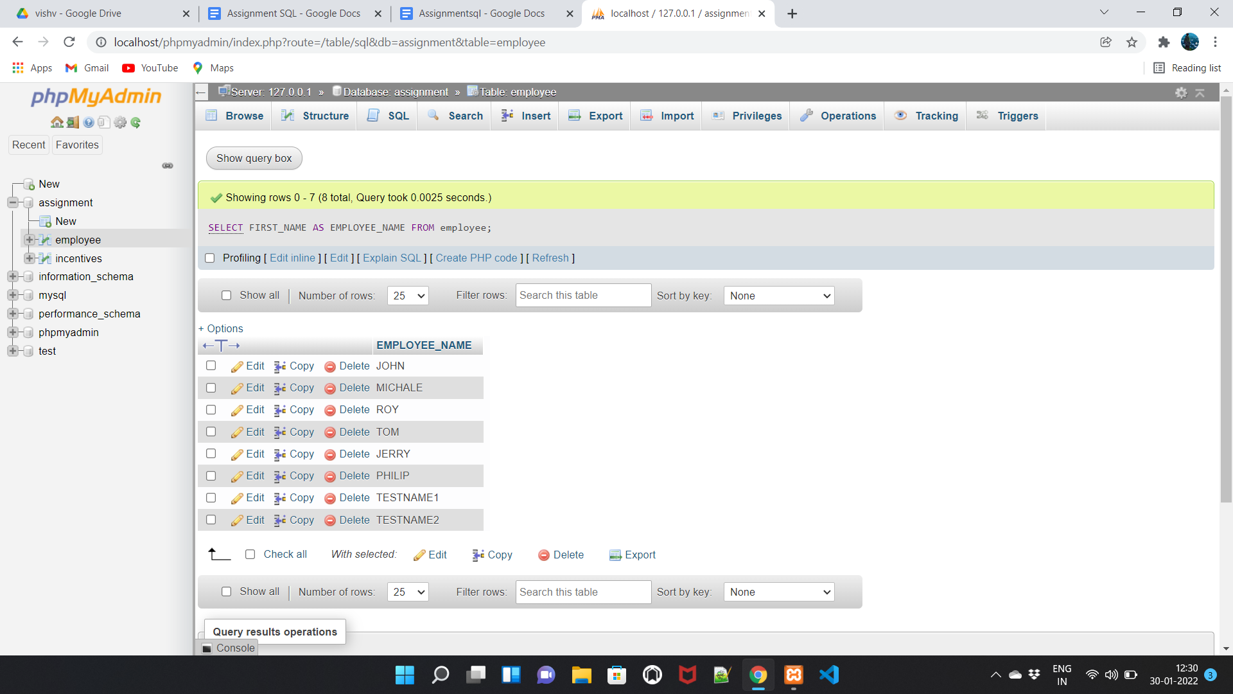

**B2. Get FIRST_NAME, Joining year, Joining Month and Joining Date from employee table.**

SELECT FIRST_NAME,JOINING_DATE FROM employee;

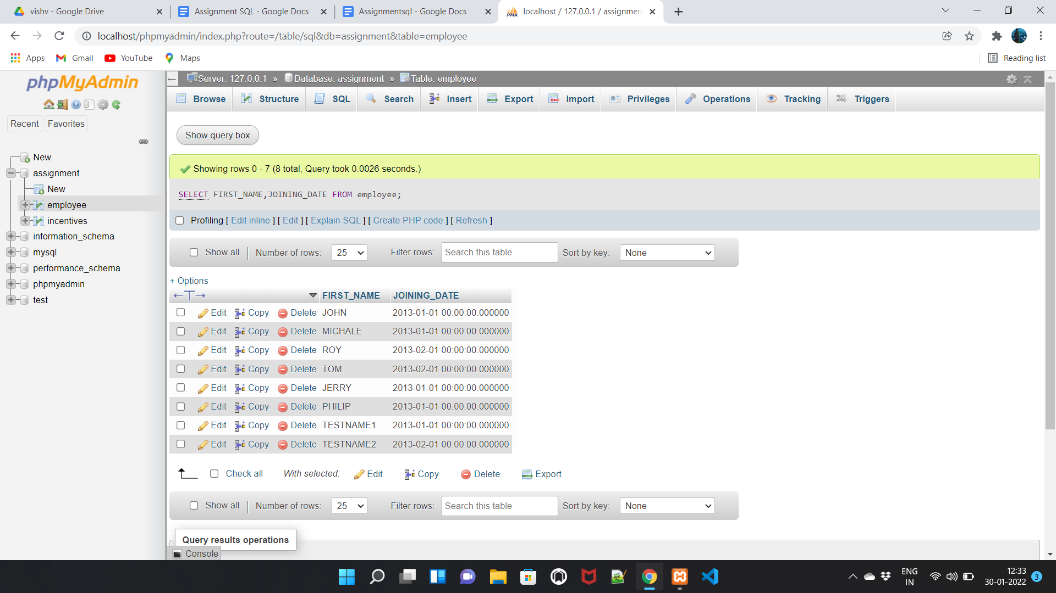

**B3. Get all employee details from the employee table order by First_Name Ascending and Salary descending.**

SELECT * FROM employee

ORDER BY FIRST_NAME ASC,SALARY DESC;

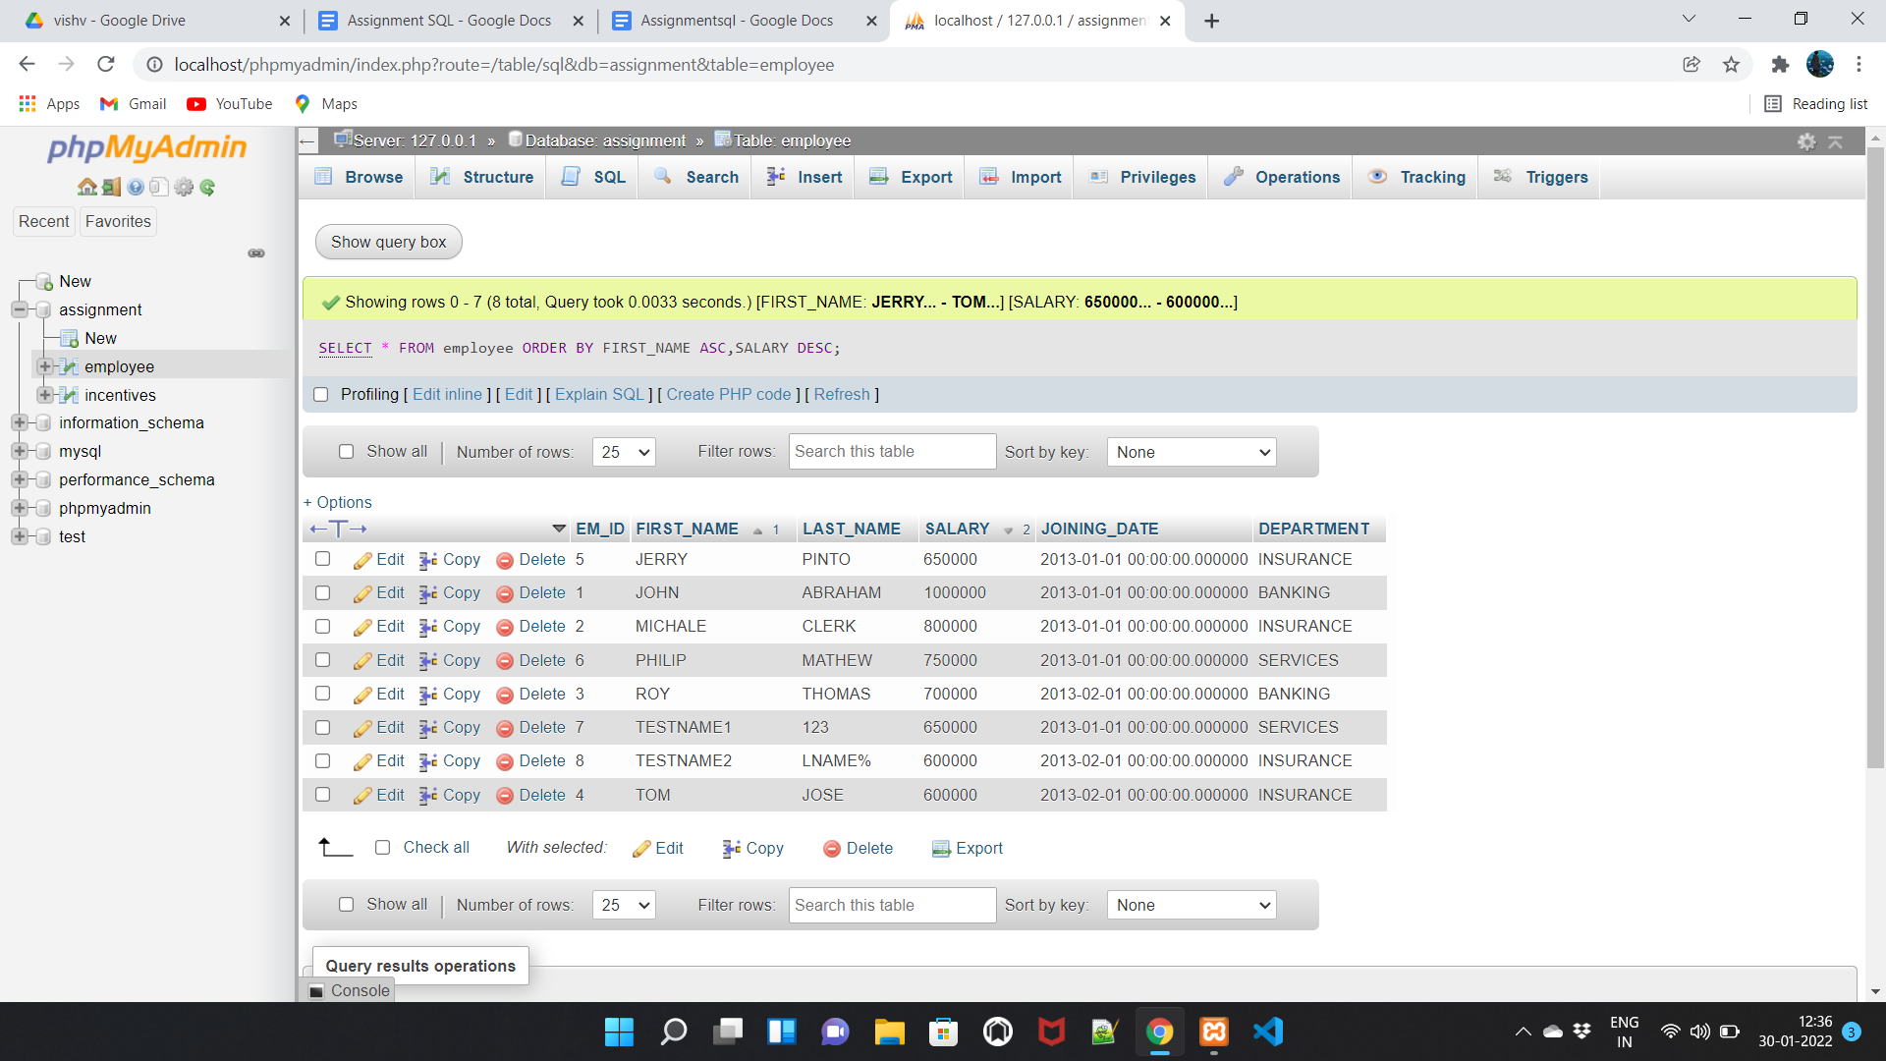

**B4. Get employee details from employee table whose first name contains ‘o’.**

SELECT * FROM employee

WHERE FIRST_NAME LIKE '%O%';

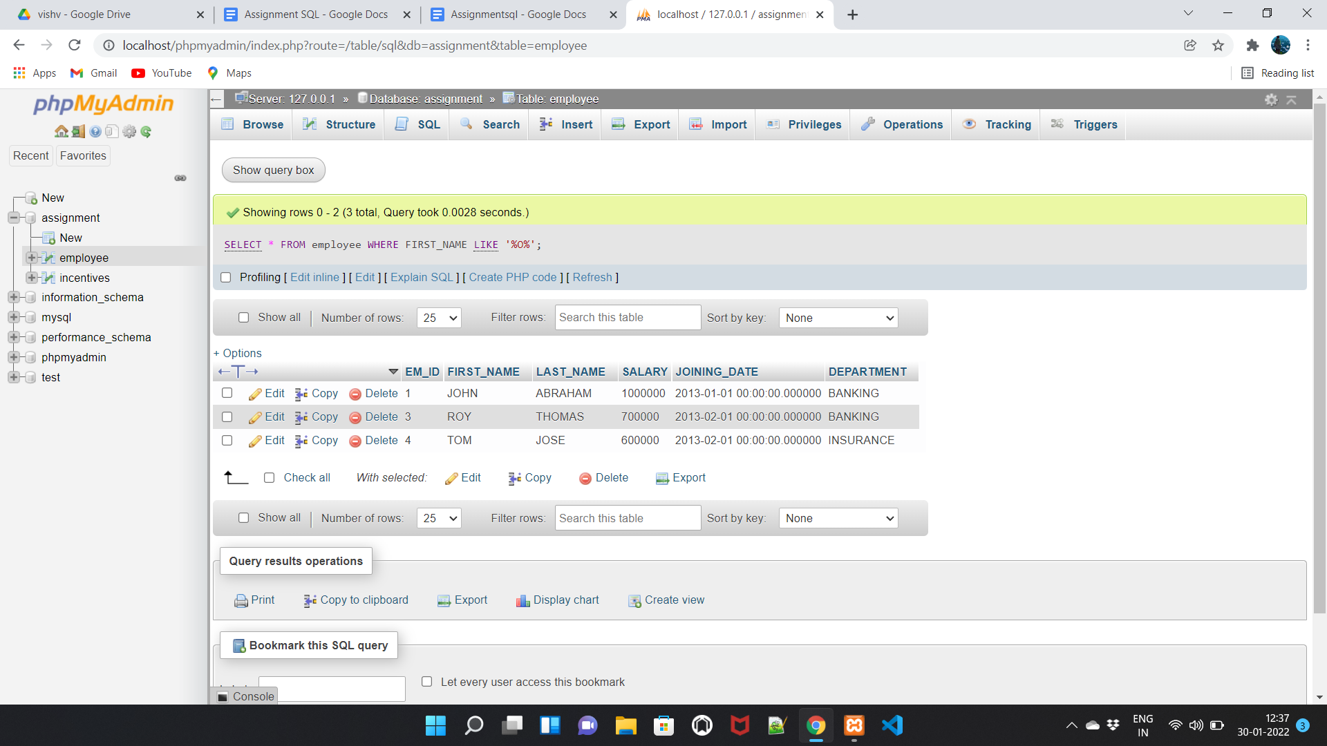

**I1. Get employee details from employee table whose joining month is “January”.**

SELECT * FROM employee

WHERE MONTH(JOINING_DATE)='01';

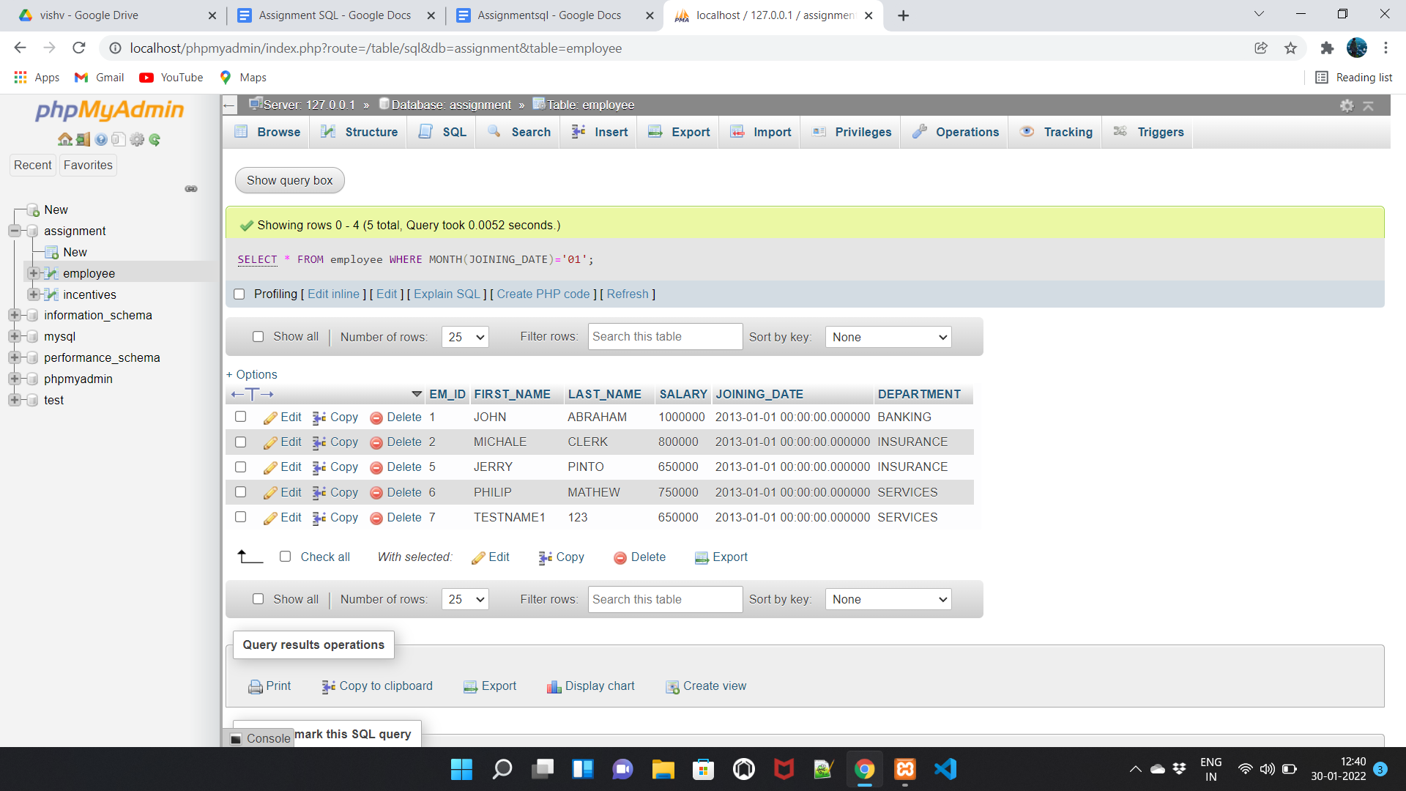

**I2. Get department, totalsalarywith respect to a department fromemployee table order by total salary descending.**

**TOTAL SALARY**

SELECT SUM(SALARY) FROM employee;

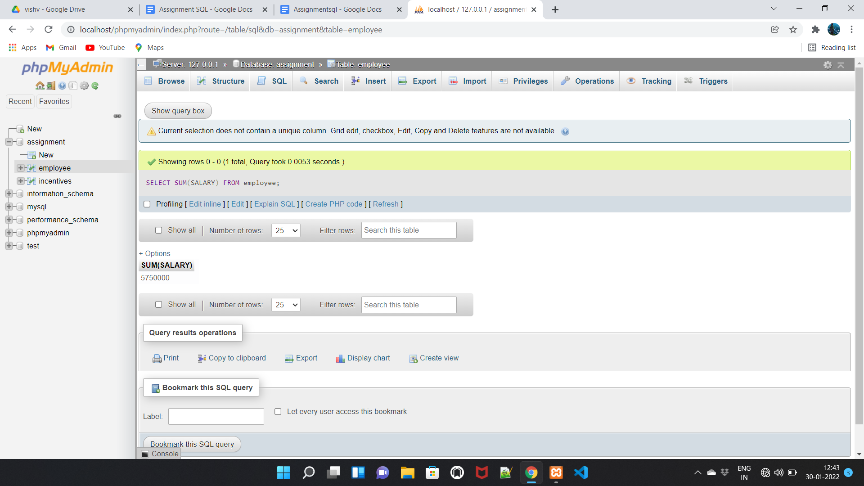

**Get department and salary decending**

SELECT DEPARTMENT,SALARY FROM employee

ORDER BY SALARY DESC;

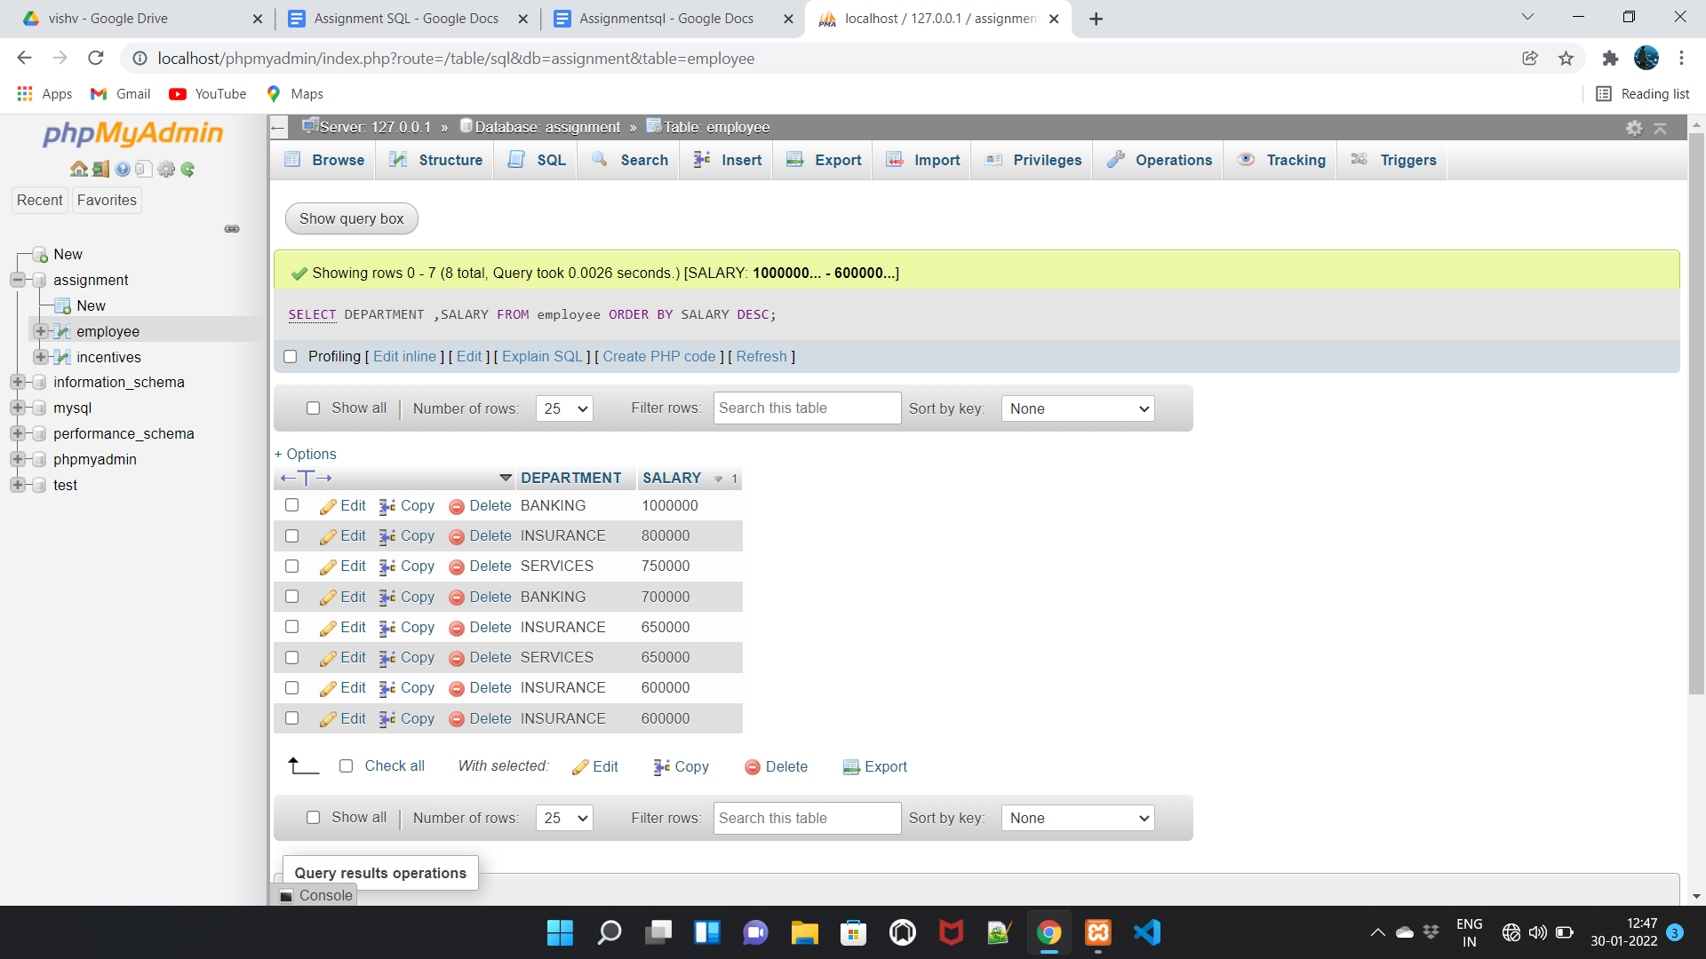

SELECT DEPARTMENT,SUM(SALARY) FROM employee

ORDER BY SALARY DESC;

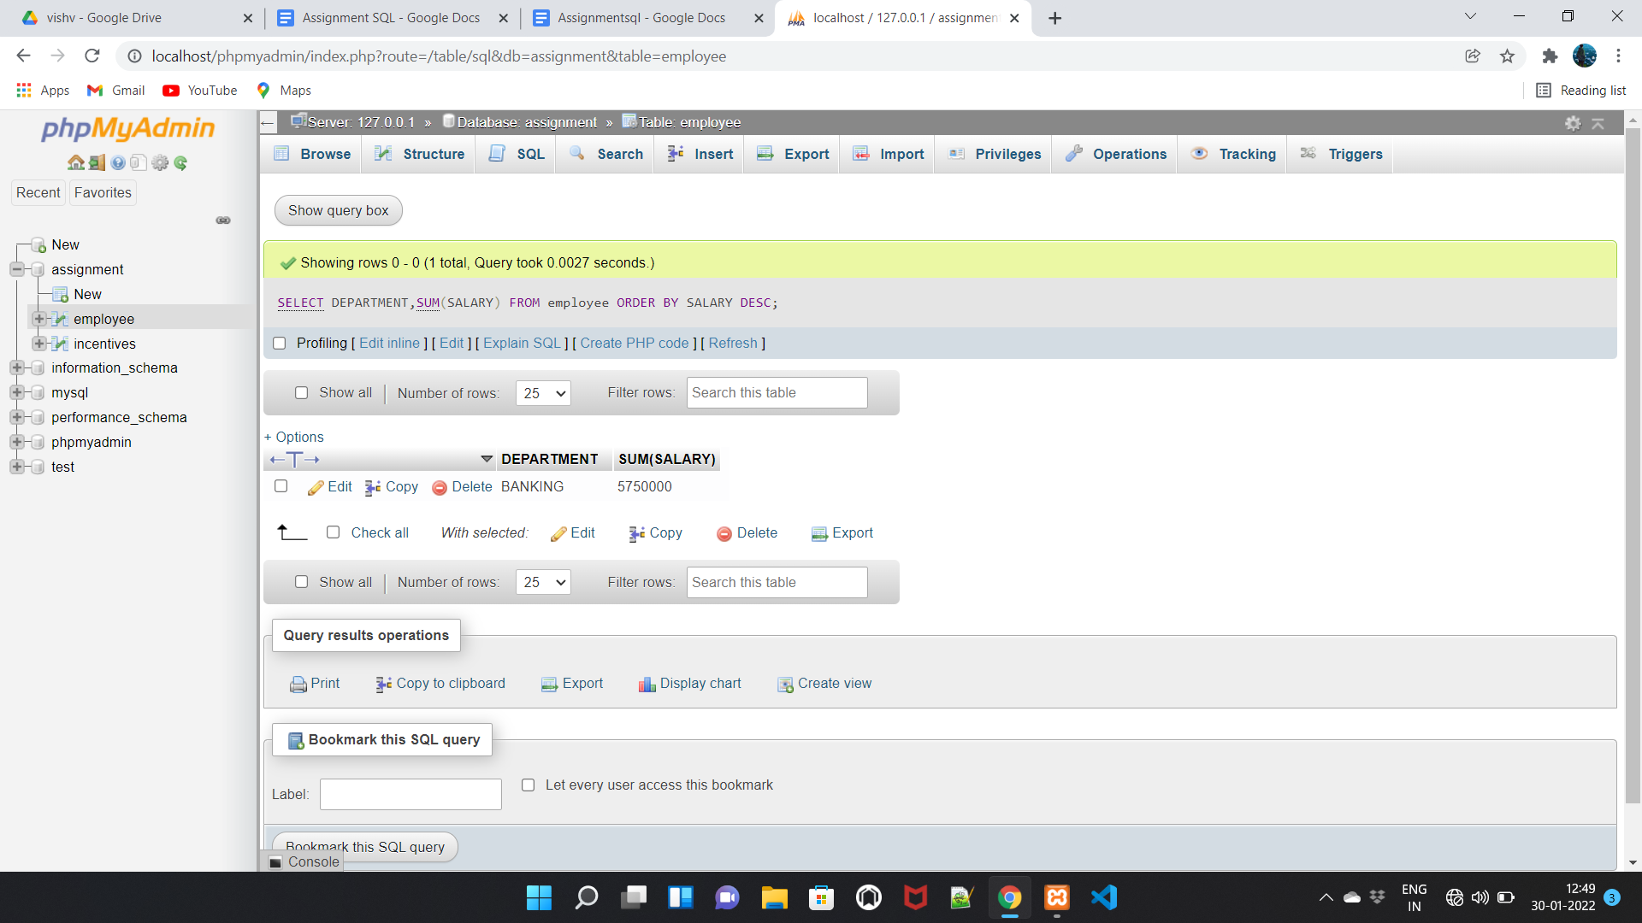

**I3. Get department wise maximum salary from employee table order by salary ascending.**

SELECT DEPARTMENT,MAX(SALARY) FROM employee GROUP BY DEPARTMENT;

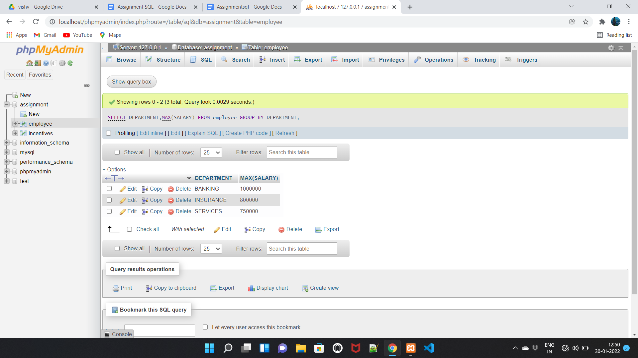

SELECT DEPARTMENT,MAX(SALARY) FROM employee GROUP BY DEPARTMENT,SALARY ASC;

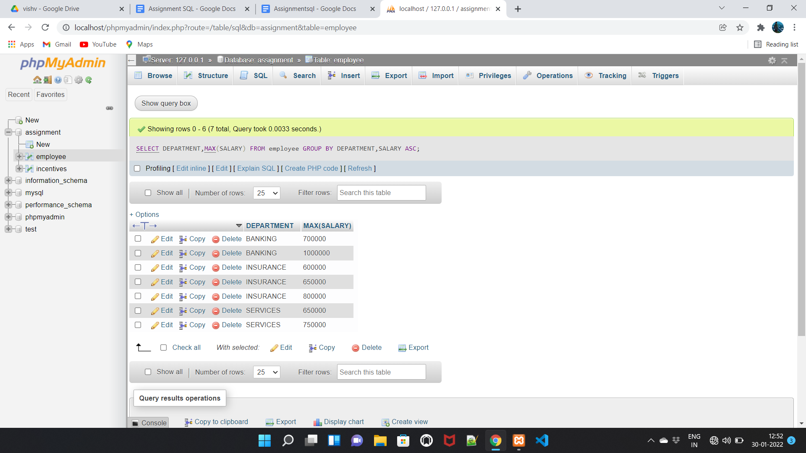

**I4. Select first_name, incentive amount from employee and incentives table for those employees who have incentives and incentive amount greater than 3000**

SELECT employee.FIRST_NAME,incentives.INCENTIVE_AMT

FROM employee INNER JOIN incentives

ON employee.EM_ID=incentives.EMPLOYEE_REF_ID

WHERE INCENTIVE_AMT>3000;

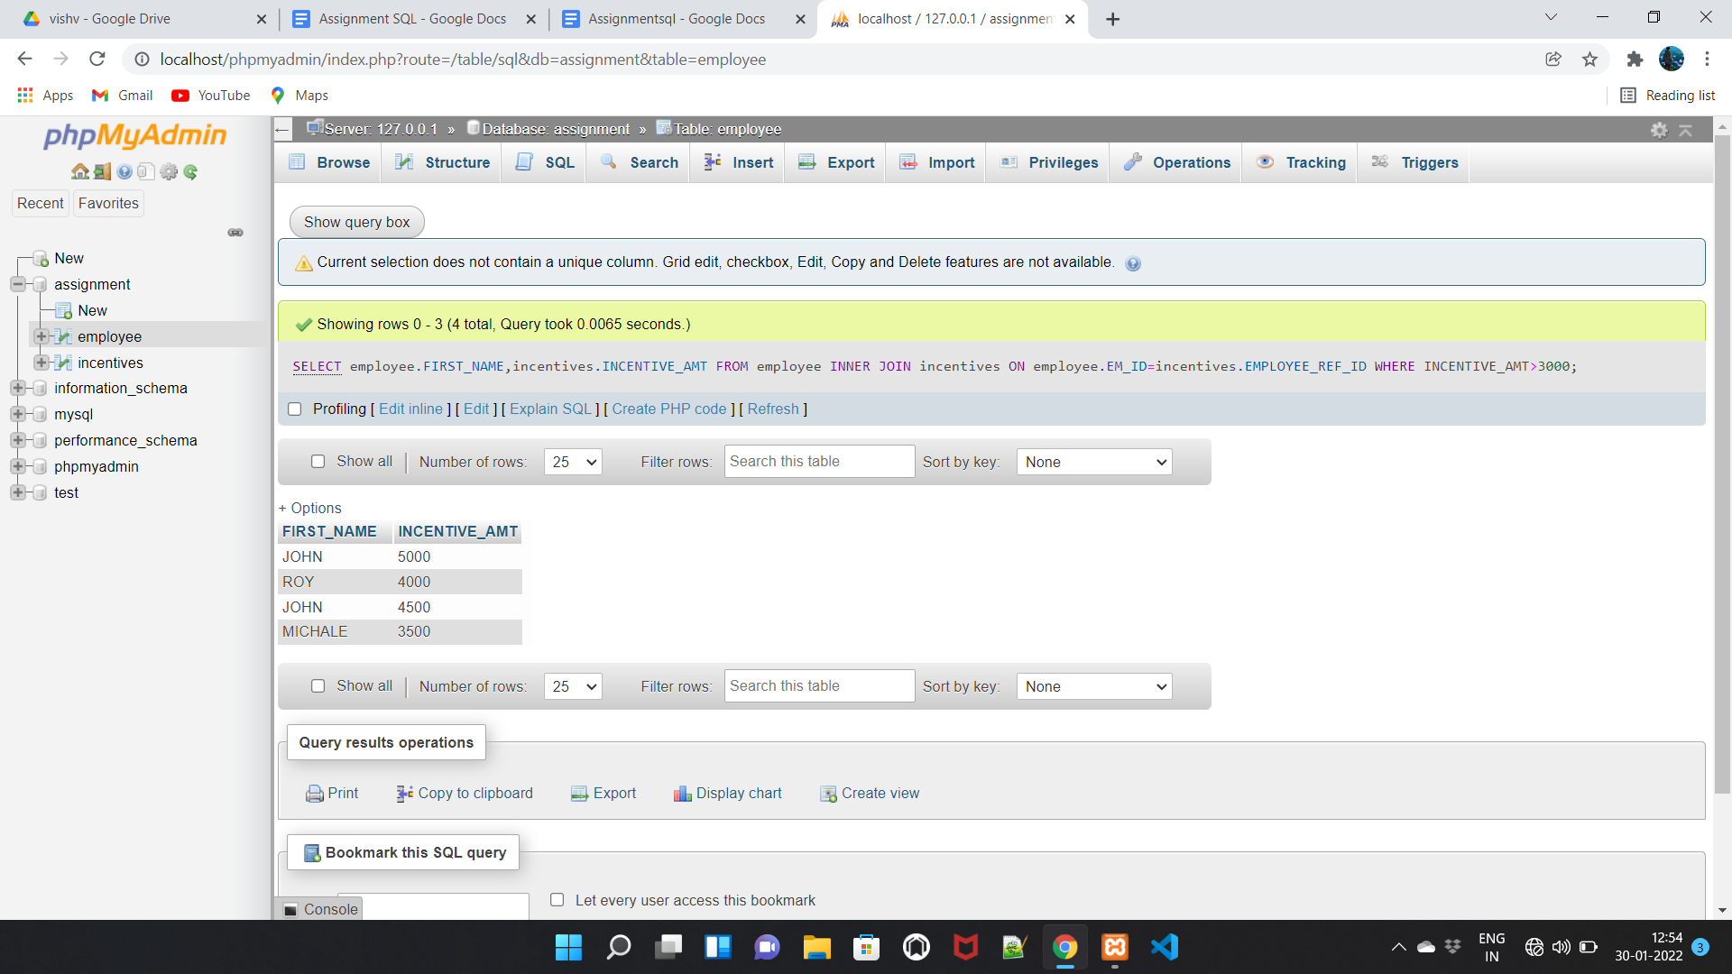

**A1. Select 2nd Highest salary from employee table.**

select *from employee

group by SALARY

order by SALARY desc limit 1,1;

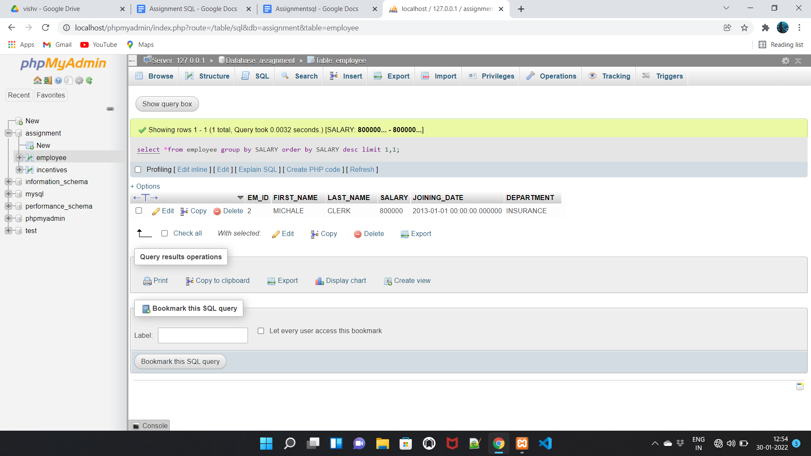

**A2. Select first_name, incentive amount from employee and incentives table for all employees who got incentives using left join**

SELECT employee.FIRST_NAME,incentives.INCENTIVE_AMT

FROM employee LEFT JOIN incentives

ON employee.EM_ID=incentives.EMPLOYEE_REF_ID;

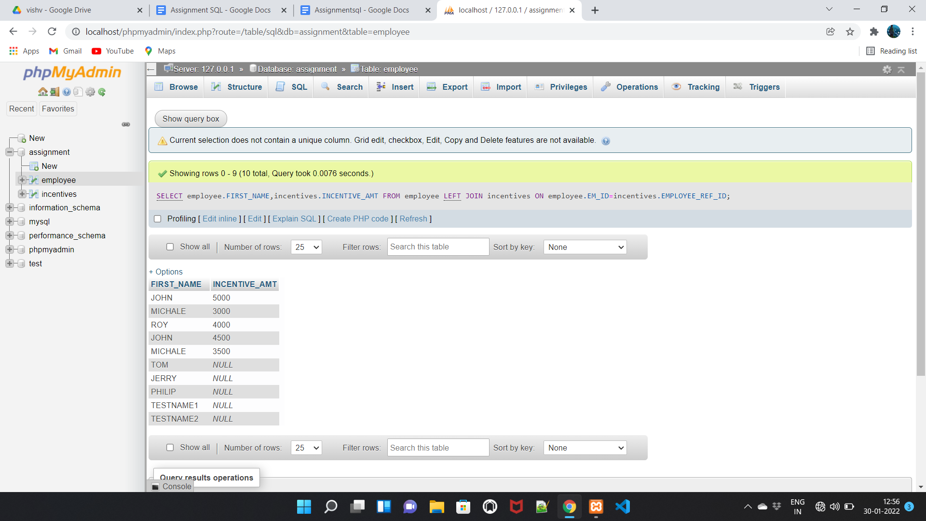

**A3. Create View OF Employee table in which store first name ,last name and salary only.**

SELECT FIRST_NAME,LAST_NAME,SALARY FROM employee;

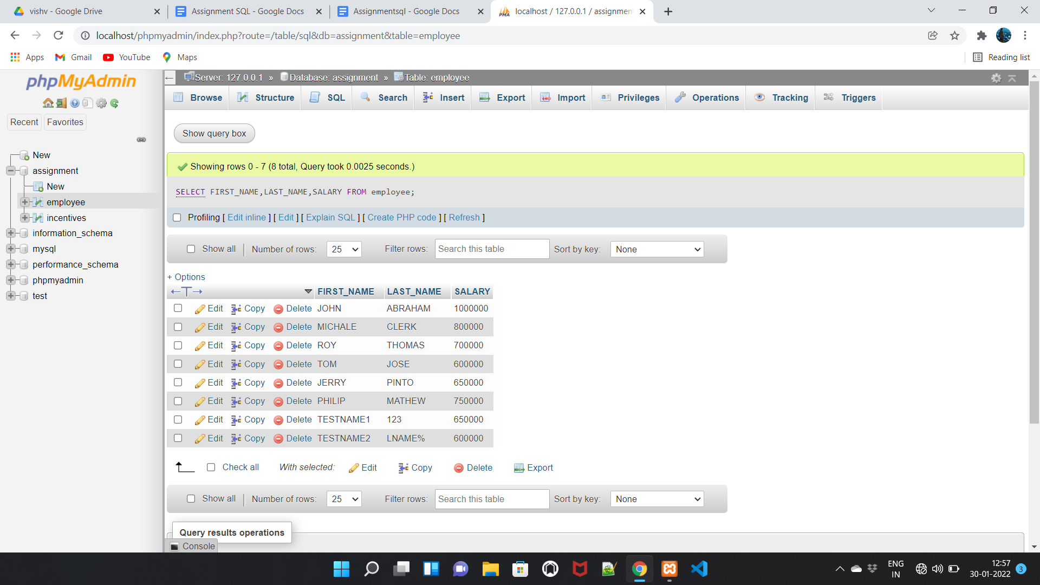

**A4. Create Procedure to find out department wise highest salary.**

SELECT DEPARTMENT,MAX(SALARY) FROM employee GROUP BY DEPARTMENT;

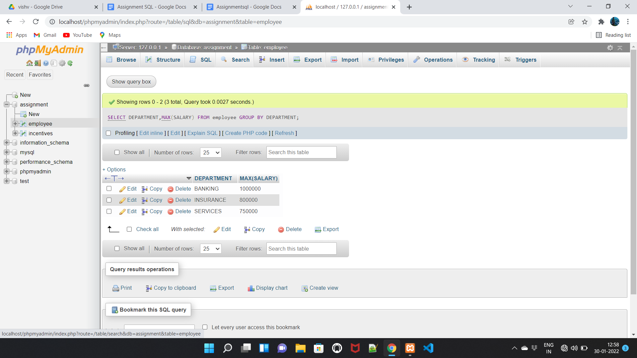

**A5. Create After Insert trigger on Employee table which insert records in view table.**

**TASK:-2**

**TABLE : SALES PERSON**

CREATE TABLE SALES_PERSON(SNO INT PRIMARY KEY AUTO-INCREMENT,SNAME VARCHAR(255),CITY VARCHAR(255),COMM FLOAT);

INSERT INTO sales_person(SNO,SNAME,CITY,COMM)VALUES(“1001”,”PEEL”,”LONDON”,”0.12”);

INSERT INTO sales_person(SNO,SNAME,CITY,COMM)VALUES("1002","SERRES","SAN JOSE","0.13");

INSERT INTO sales_person(SNO,SNAME,CITY,COMM)VALUES("1003","AXELROD","NEW YORK","0.1");

INSERT INTO sales_person(SNO,SNAME,CITY,COMM)VALUES("1004","MOTIKA","LONDON","0.11");

INSERT INTO sales_person(SNO,SNAME,CITY,COMM)VALUES("1007","RAFKIN","BARCELONA","0.15");

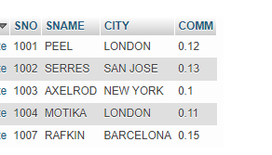

**TABLE : CUSTOMER**

CREATE TABLE CUSTOMER(CNM INT PRIMARY KEY AUTO_INCREMENT,CNAME VARCHAR(255),CITY VARCHAR(255),RATING INT,SNO INT, FOREIGN KEY(SNO)REFERENCES sales_person(SNO));

INSERT INTO customer(CNM,CNAME,CITY,RATING,SNO)VALUES("201","HOFFMAN","LONDON","100","1001");

INSERT INTO customer(CNM,CNAME,CITY,RATING,SNO)VALUES("202","GIOVANNE","ROME","200","1003");

INSERT INTO customer(CNM,CNAME,CITY,RATING,SNO)VALUES("203","LIU","SAN JOSE","300","1002");

INSERT INTO customer(CNM,CNAME,CITY,RATING,SNO)VALUES("204","GRASS","BARCELONA","100","1002");

INSERT INTO customer(CNM,CNAME,CITY,RATING,SNO)VALUES("206","CLEMENS","LONDON","00","1007");

INSERT INTO customer(CNM,CNAME,CITY,RATING,SNO)VALUES("207","PEREIRA","ROME","100","1004");

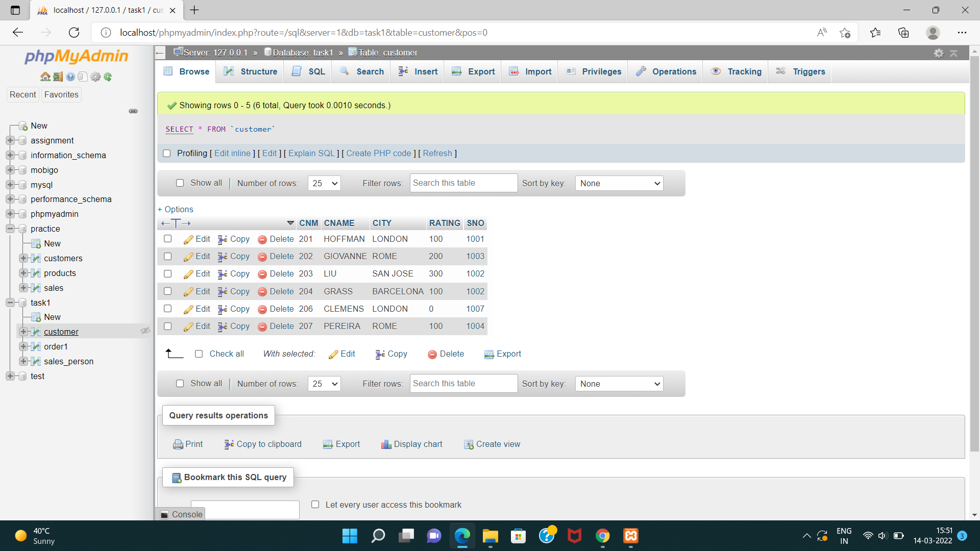

**TABLE : ORDER1**

CREATE TABLE ORDER1(ONM INT PRIMARY KEY AUTO_INCREMENT,AMT INT,ODE DATETIME,CNM INT,SNO INT,FOREIGN KEY(CNM)REFERENCES customer(CNM),FOREIGN KEY(SNO)REFERENCES sales_person(SNO));

INSERT INTO order1(ONM,AMT,ODE,CNM,SNO)VALUES("3001","18.69","1994-10-03","201","1007");

INSERT INTO order1(ONM,AMT,ODE,CNM,SNO)VALUES("3002","1900.1","1994-10-03","207","1004");

INSERT INTO order1(ONM,AMT,ODE,CNM,SNO)VALUES("3003","767.19","1994-10-03","201","1001");

INSERT INTO order1(ONM,AMT,ODE,CNM,SNO)VALUES("3005","3005","1994-10-03","203","1002");

INSERT INTO order1(ONM,AMT,ODE,CNM,SNO)VALUES("3006","3006","1994-10-04","201","1007");

INSERT INTO order1(ONM,AMT,ODE,CNM,SNO)VALUES("3007","3007","1994-10-05","204","1002");

INSERT INTO order1(ONM,AMT,ODE,CNM,SNO)VALUES("3008","3008","1994-10-05","206","1001");

INSERT INTO order1(ONM,AMT,ODE,CNM,SNO)VALUES("3009","3009","1994-10-04","202","1003");

INSERT INTO order1(ONM,AMT,ODE,CNM,SNO)VALUES("3010","3010","1994-10-06","204","1002");

INSERT INTO order1(ONM,AMT,ODE,CNM,SNO)VALUES("3011","3011","1994-10-06","206","1001");

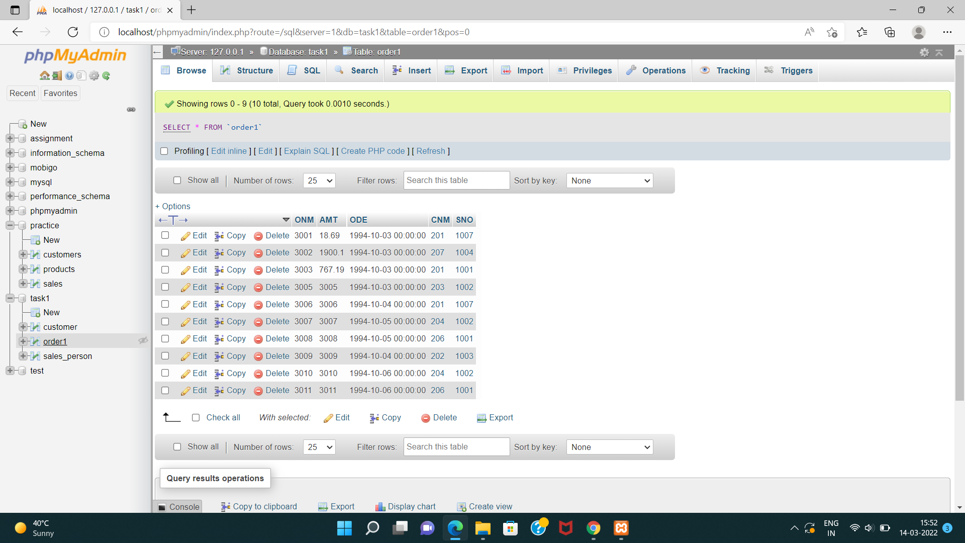

**QUERY**

B1) All orders for more than $1000

SELECT * FROM order1 WHERE AMT>1000;

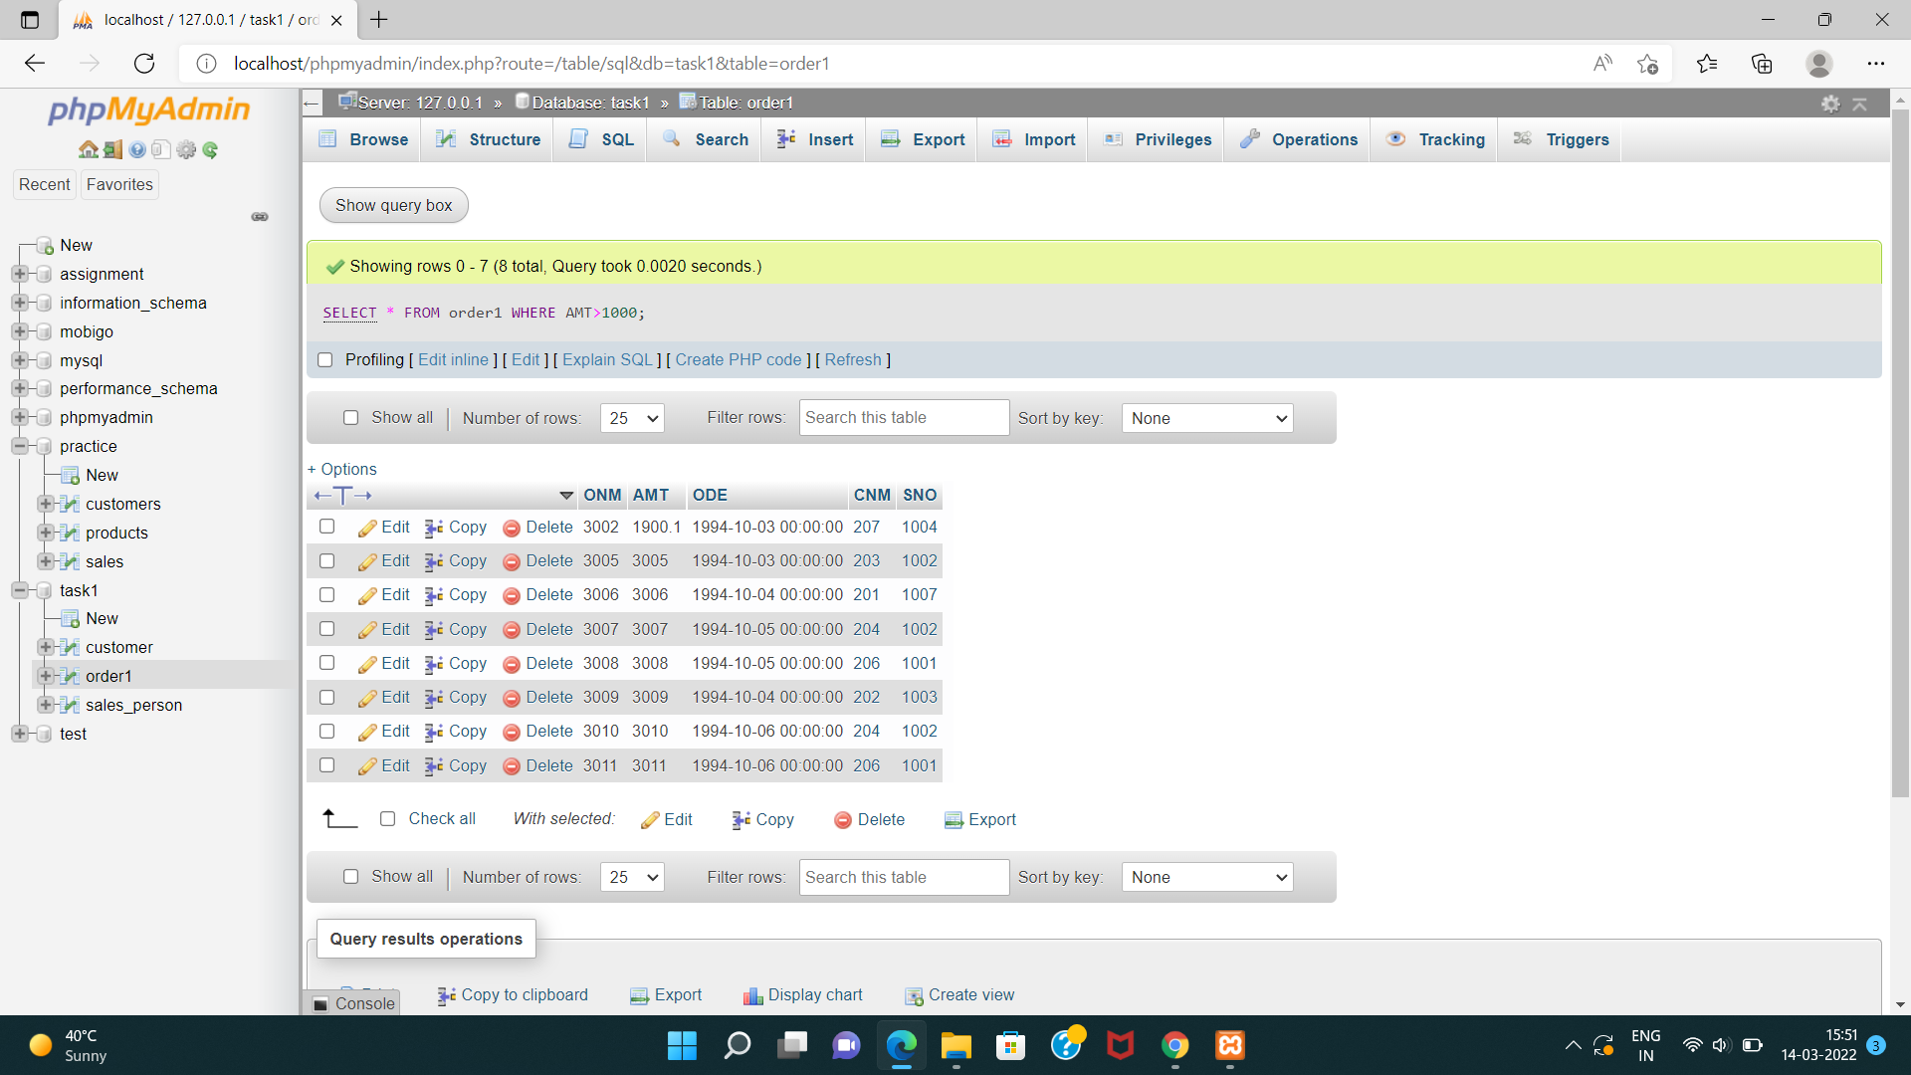

**B2)Names and cities of all salespeople in London with commission above 0.10.**

SELECT SNAME,CITY FROM sales_person WHERE CITY='London' AND COMM>0.10;

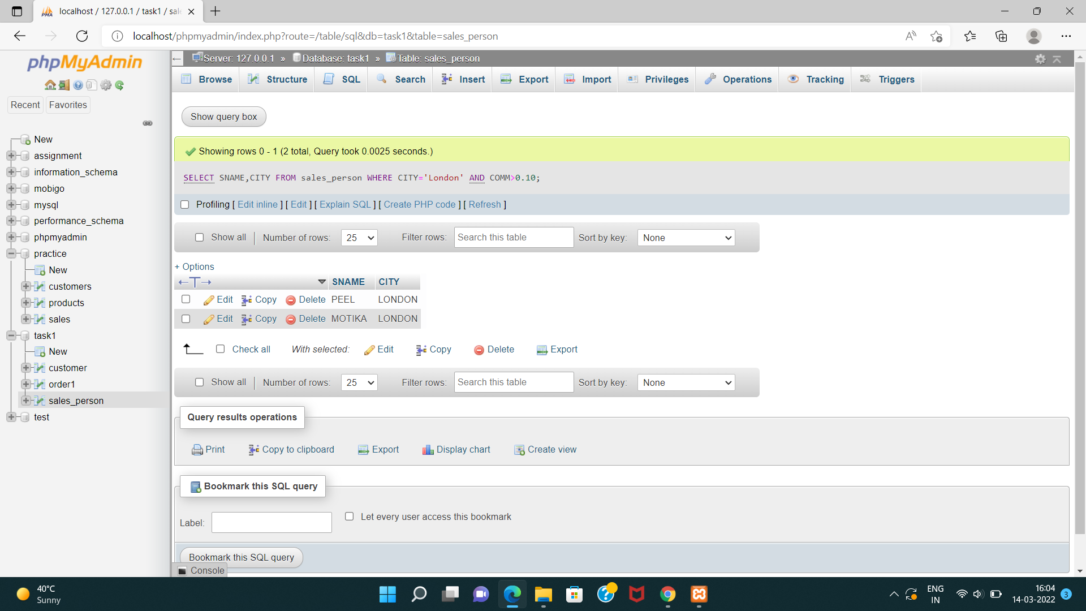

**B3). All salespeople either in Barcelona or in London.**

SELECT * FROM sales_person

WHERE CITY='BARCELONA' OR City='LONDON';

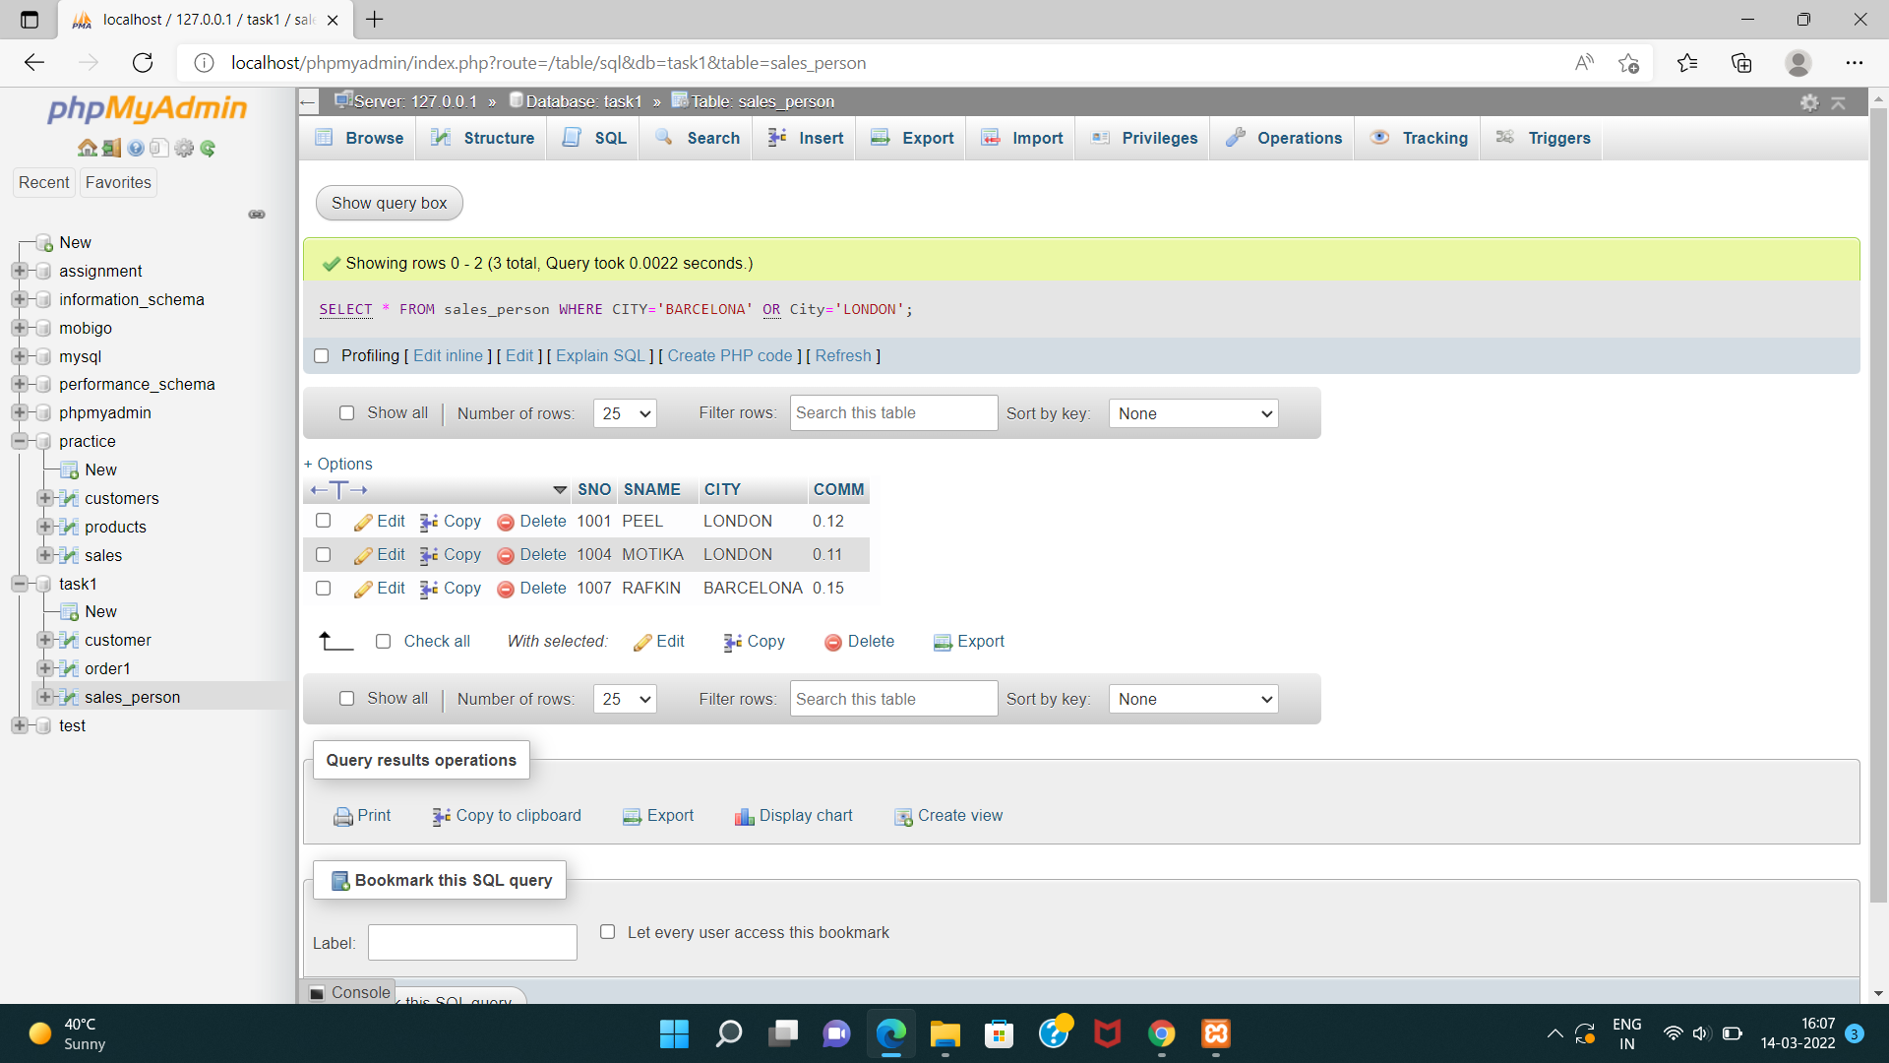

**B4). All salespeople with commission between 0.10 and 0.12.(Boundary values should be excluded).**

SELECT * FROM sales_person

WHERE COMM BETWEEN 0.10 AND 0.12;

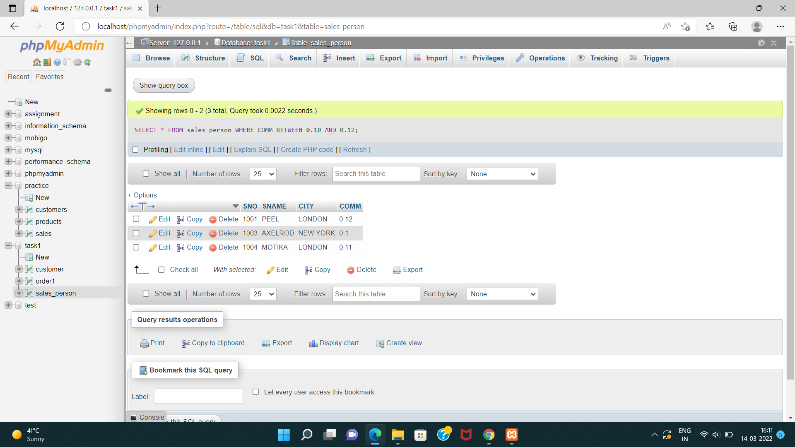

**B5). All customers with NULL values in city column.**

**I1). All orders taken on Oct 3Rd and Oct 4th 1994.**

**I2). All customers serviced by peel or Motika.**

**I3). All customers whose names begin with a letter from A to B I4. All customers excluding those with rating <= 100 unless they are located in Rome.**

**A1). All orders except those with 0 or NULL value in amt field.**

**A2). Count the number of salespeople currently listing orders in the order table.**

**TASK-3**

**CREATE DATABASE** : PRACTICE

CREATE DATABASE PRACTICE;

**TABLE**:PRODUCTS

CREATE TABLE PRODUCTS(tID int PRIMARY key AUTO_INCREMENT,ProductName varchar(20),RecommendedPrice int,Categoey varchar(10));

**INSERT DATA**

INSERT INTO products(tID,ProductName,RecommendedPrice,Categoey)VALUES("1","DVD","105.00","LivingRoom");

INSERT INTO products(tID,ProductName,RecommendedPrice,Categoey)VALUES("2","Microwave","98.00","Kitchen");

INSERT INTO products(tID,ProductName,RecommendedPrice,Categoey)VALUES("3","Monitor","200.00","Office");

INSERT INTO products(tID,ProductName,RecommendedPrice,Categoey)VALUES("4","Speakers","85.00","Office");

INSERT INTO products(tID,ProductName,RecommendedPrice,Categoey)VALUES("5","Refrigerator","900.00","Kitchen");

INSERT INTO products(tID,ProductName,RecommendedPrice,Categoey)VALUES("6","VCR","165.00","LivingRoom");

INSERT INTO products(tID,ProductName,RecommendedPrice,Categoey)VALUES("7","CoffePot","35.00","Kitchen");

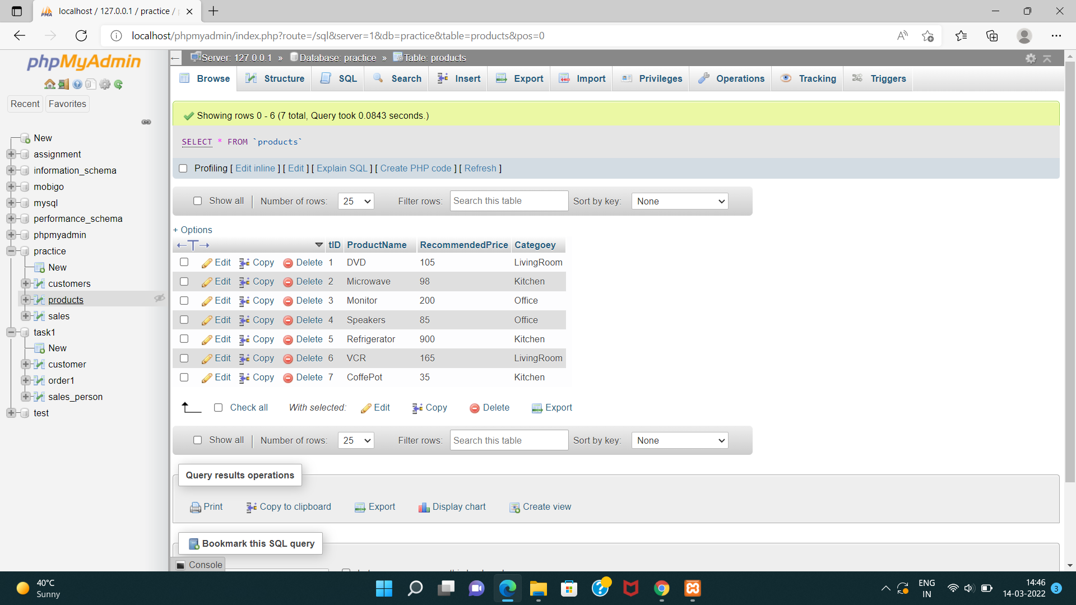

**TABLE**: CUSTOMERS

CREATE TABLE CUSTOMERS(CustomerId int PRIMARY KEY AUTO_INCREMENT,FirstName varchar(50),LastName varchar(50),City varchar(50));

**INSERT DATA**

INSERT INTO customers(CustomerId,FirstName,LastName,City,State,Zip)VALUES("","Chintan","Patel","Anand","GJ","388001");

INSERT INTO customers(CustomerId,FirstName,LastName,City,State,Zip)VALUES("","Paresh","Prajapti","Nadiad","GJ","387001");

INSERT INTO customers(CustomerId,FirstName,LastName,City,State,Zip)VALUES("","Pragnesh","Patel","Surat","GJ","395008");

INSERT INTO customers(CustomerId,FirstName,LastName,City,State,Zip)VALUES("","NIlesh","Dharsandia","Mumbai","MH","400002");

INSERT INTO customers(CustomerId,FirstName,LastName,City,State,Zip)VALUES("","Sonal","Patel","Mumbai","MH","400002");

INSERT INTO customers(CustomerId,FirstName,LastName,City,State,Zip)VALUES("","Harshal","Patel","Mogri","GJ","388345");

INSERT INTO customers(CustomerId,FirstName,LastName,City,State,Zip)VALUES("","Prakash","Rathod","Mogri","GJ","388345");

INSERT INTO customers(CustomerId,FirstName,LastName,City,State,Zip)VALUES("","Aarzoo","Dodhiya","Rajkot","GJ","360006");

INSERT INTO customers(CustomerId,FirstName,LastName,City,State,Zip)VALUES("","Heta","Dave","Varanasi","UP","221002");

INSERT INTO customers(CustomerId,FirstName,LastName,City,State,Zip)VALUES("","NIkita","Dave","Varanasi","UP","221002");

INSERT INTO customers(CustomerId,FirstName,LastName,City,State,Zip)VALUES("","Vaibhav","Dave","Varanasi","UP","221002");

INSERT INTO customers(CustomerId,FirstName,LastName,City,State,Zip)VALUES("","Paresh","Patel","Pune","MH","411001");

INSERT INTO customers(CustomerId,FirstName,LastName,City,State,Zip)VALUES("","Prakash","Patel","Pune","MH","411001");

INSERT INTO customers(CustomerId,FirstName,LastName,City,State,Zip)VALUES("","Sandhya","Patel","Hyedrabad","AP","500031");

INSERT INTO customers(CustomerId,FirstName,LastName,City,State,Zip)VALUES("","Divesh","Patel","Banglore","KA","560002");

INSERT INTO customers(CustomerId,FirstName,LastName,City,State,Zip)VALUES("","Payal","Shah","Banglore","KA","560002");

INSERT INTO customers(CustomerId,FirstName,LastName,City,State,Zip)VALUES("","Priyanka","Rana","Anand","GJ","388001");

INSERT INTO customers(CustomerId,FirstName,LastName,City,State,Zip)VALUES("","Sanket","Dhebar","V.V.Nagar","GJ","388121");

INSERT INTO customers(CustomerId,FirstName,LastName,City,State,Zip)VALUES("","Puja","Shah","Varanasi","UP","221002");

INSERT INTO customers(CustomerId,FirstName,LastName,City,State,Zip)VALUES("","Priya","Shah","Varanasi","UP","221002");

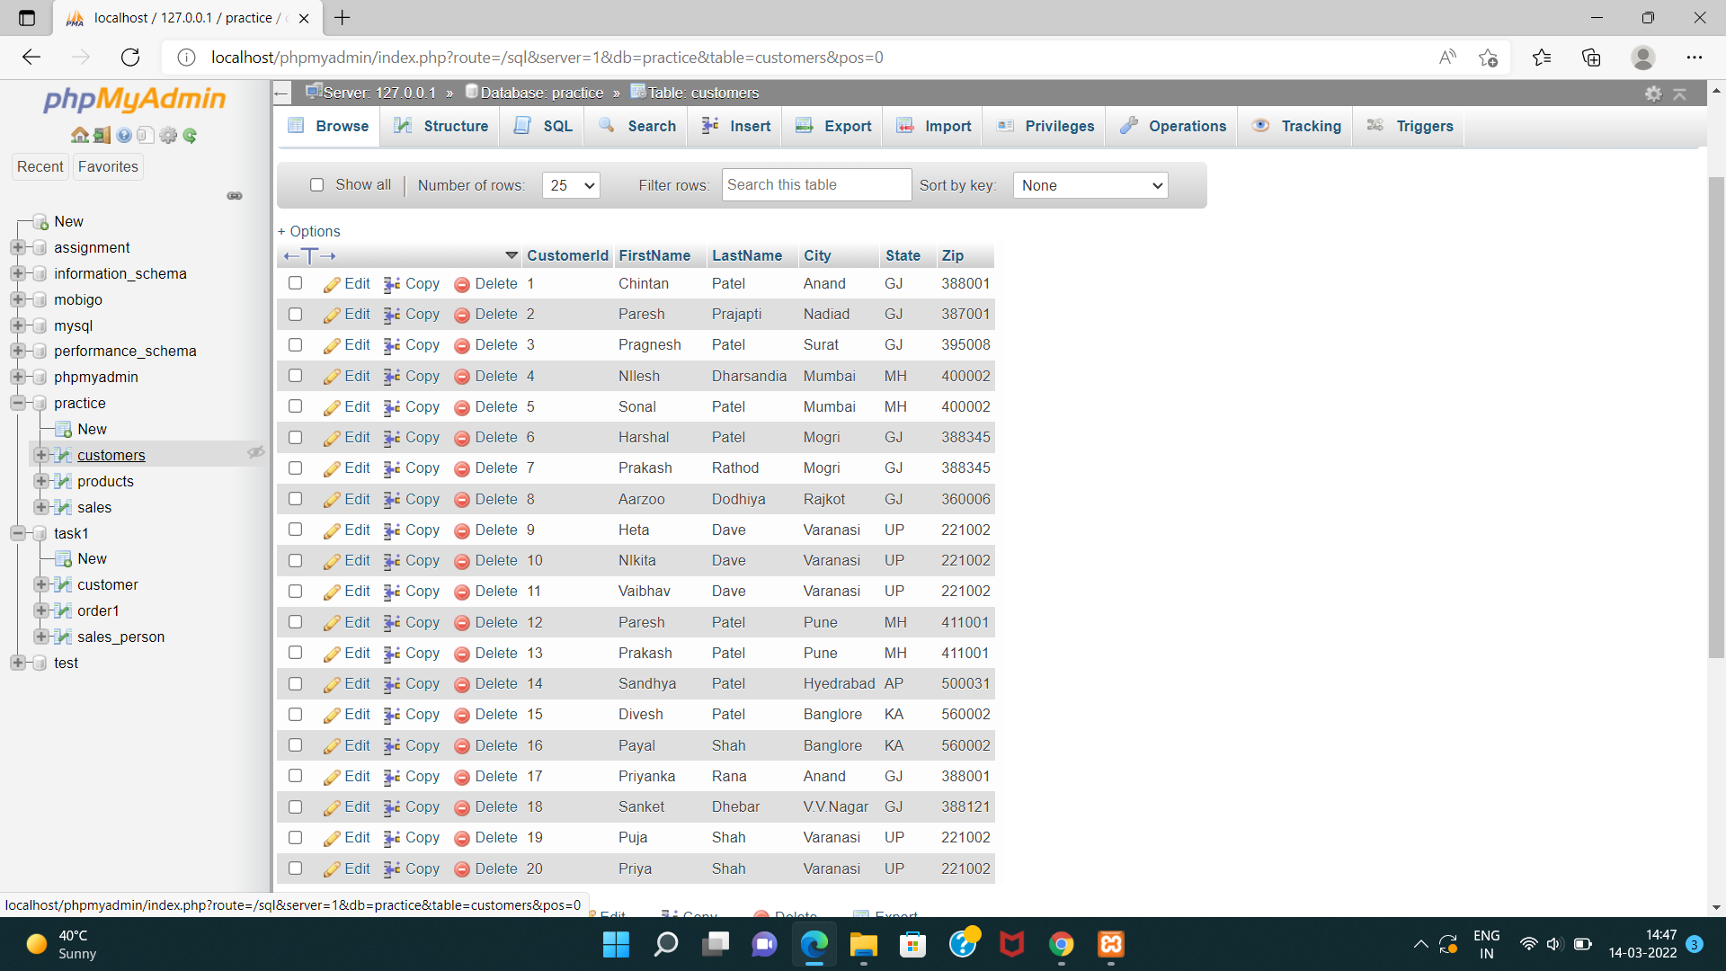

**TABLE**: SALES

CREATE TABLE sales(SalesId int PRIMARY KEY AUTO_INCREMENT,ProductId int,CustomerId int,SalesPrice float(6),SalesDate datetime,FOREIGN KEY(ProductId)REFERENCES products(tID),FOREIGN KEY(CustomerId)REFERENCES customers(CustomerId));

**INSERT DATA**

INSERT INTO sales(SalesId,ProductId,CustomerId,SalesPrice,SalesDate)VALUES("","1","1","130.00","2005-06-14");

INSERT INTO sales(SalesId,ProductId,CustomerId,SalesPrice,SalesDate)VALUES("","2","2","97.00","2005-06-19");

INSERT INTO sales(SalesId,ProductId,CustomerId,SalesPrice,SalesDate)VALUES("","3","3","200.00","2005-09-20");

INSERT INTO sales(SalesId,ProductId,CustomerId,SalesPrice,SalesDate)VALUES("","4","4","80.00","2005-03-22");

INSERT INTO sales(SalesId,ProductId,CustomerId,SalesPrice,SalesDate)VALUES("","5","5","899.00","2005-01-23");

INSERT INTO sales(SalesId,ProductId,CustomerId,SalesPrice,SalesDate)VALUES("","6","6","150.00","2005-03-24");

INSERT INTO sales(SalesId,ProductId,CustomerId,SalesPrice,SalesDate)VALUES("","3","7","209.00","2005-03-10");

INSERT INTO sales(SalesId,ProductId,CustomerId,SalesPrice,SalesDate)VALUES("","4","8","90.00","2005-08-11");

INSERT INTO sales(SalesId,ProductId,CustomerId,SalesPrice,SalesDate)VALUES("","6","9","130.00","2005-08-12");

INSERT INTO sales(SalesId,ProductId,CustomerId,SalesPrice,SalesDate)VALUES("","2","14","85.00","2005-12-13");

INSERT INTO sales(SalesId,ProductId,CustomerId,SalesPrice,SalesDate)VALUES("","3","15","240.00","2005-05-14");

INSERT INTO sales(SalesId,ProductId,CustomerId,SalesPrice,SalesDate)VALUES("","1","17","87.00","2005-07-19");

INSERT INTO sales(SalesId,ProductId,CustomerId,SalesPrice,SalesDate)VALUES("","2","18","99.00","2005-09-20");

INSERT INTO sales(SalesId,ProductId,CustomerId,SalesPrice,SalesDate)VALUES("","6","19","150.00","2005-07-22");

INSERT INTO sales(SalesId,ProductId,CustomerId,SalesPrice,SalesDate)VALUES("","5","5","900.00","2005-03-06");

INSERT INTO sales(SalesId,ProductId,CustomerId,SalesPrice,SalesDate)VALUES("","4","6","86.00","2005-04-07");

INSERT INTO sales(SalesId,ProductId,CustomerId,SalesPrice,SalesDate)VALUES("","2","7","88.00","2005-11-08");

INSERT INTO sales(SalesId,ProductId,CustomerId,SalesPrice,SalesDate)VALUES("","3","8","198.00","2005-05-09");

INSERT INTO sales(SalesId,ProductId,CustomerId,SalesPrice,SalesDate)VALUES("","1","9","150.00","2005-10-10");

INSERT INTO sales(SalesId,ProductId,CustomerId,SalesPrice,SalesDate)VALUES("","6","14","99.00","2005-05-09");

INSERT INTO sales(SalesId,ProductId,CustomerId,SalesPrice,SalesDate)VALUES("","6","15","104.00","2005-09-20");

INSERT INTO sales(SalesId,ProductId,CustomerId,SalesPrice,SalesDate)VALUES("","4","14","90.00","2005-07-22");

INSERT INTO sales(SalesId,ProductId,CustomerId,SalesPrice,SalesDate)VALUES("","1","1","130.00","2005-03-06");

INSERT INTO sales(SalesId,ProductId,CustomerId,SalesPrice,SalesDate)VALUES("","2","2","102.00","2005-04-07");

INSERT INTO sales(SalesId,ProductId,CustomerId,SalesPrice,SalesDate)VALUES("","1","3","114.00","2005-11-08");

INSERT INTO sales(SalesId,ProductId,CustomerId,SalesPrice,SalesDate)VALUES("","5","4","1000.00","2005-05-09");

INSERT INTO sales(SalesId,ProductId,CustomerId,SalesPrice,SalesDate)VALUES("","5","5","1100.00","2005-10-10");

INSERT INTO sales(SalesId,ProductId,CustomerId,SalesPrice,SalesDate)VALUES("","3","6","285.00","2005-06-11");

INSERT INTO sales(SalesId,ProductId,CustomerId,SalesPrice,SalesDate)VALUES("","2","7","87.00","2005-10-12");

INSERT INTO sales(SalesId,ProductId,CustomerId,SalesPrice,SalesDate)VALUES("","3","8","300.00","2005-07-31");

INSERT INTO sales(SalesId,ProductId,CustomerId,SalesPrice,SalesDate)VALUES("","3","20","205.00","2005-12-31");